Streaming in LangGraph
Streaming means showing the AI's response gradually as it is generated, instead of waiting for the entire response to be completed.
Without streaming:
User → AI generates entire response → Display complete response
With streaming:
User → AI → "Hello" → "how" → "can" → "I" → "help" → ...
This makes the chatbot feel faster and more responsive, even though the model may take the same amount of time to generate the complete answer.
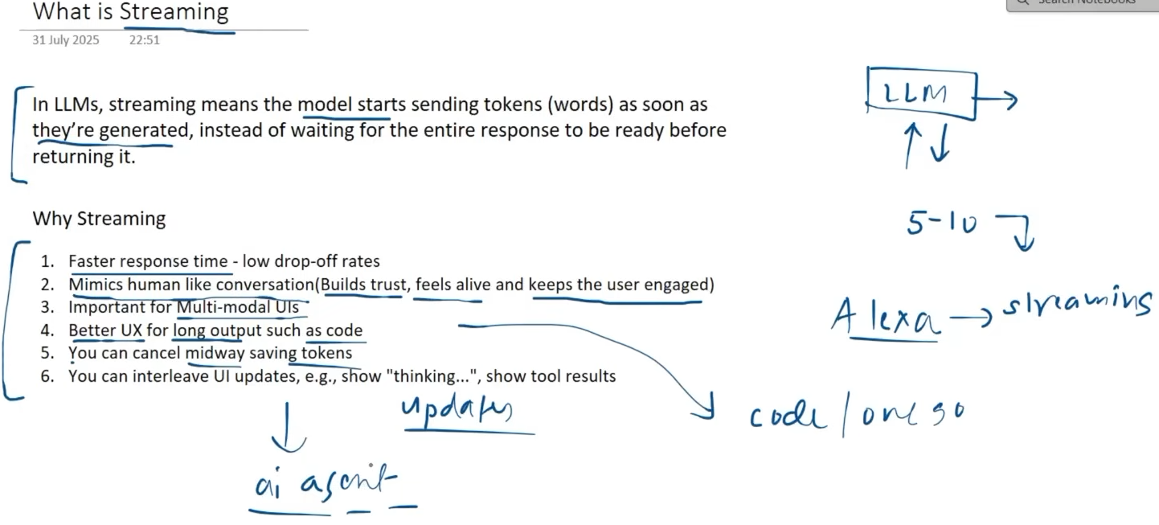

A generator is a special function that produces values one at a time instead of creating and returning all values at once.
It uses the yield keyword.
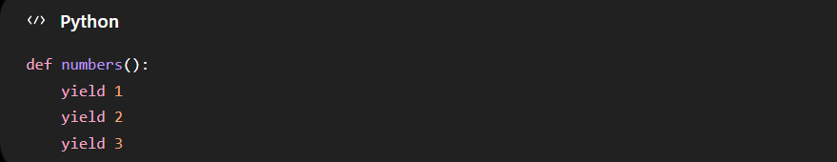

When we call it:
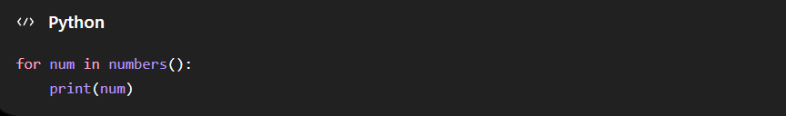
Output:
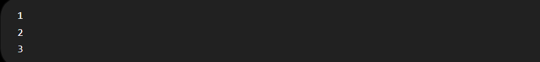Intuition: Think of a generator like a tap. It gives you one value, pauses, then gives you the next value when you ask for it.

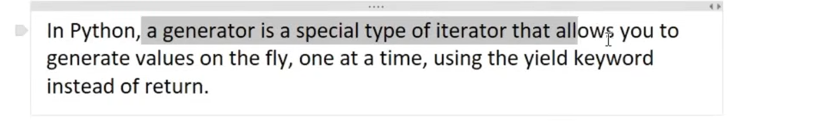

We use .stream rather than .invoke for this. And return yield.
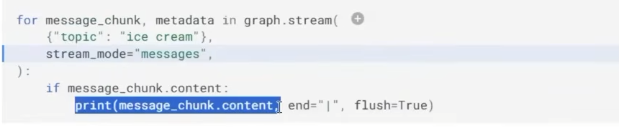
There will no change in backend code for streaming.
Code:- There is a config file to determine what chat this is.

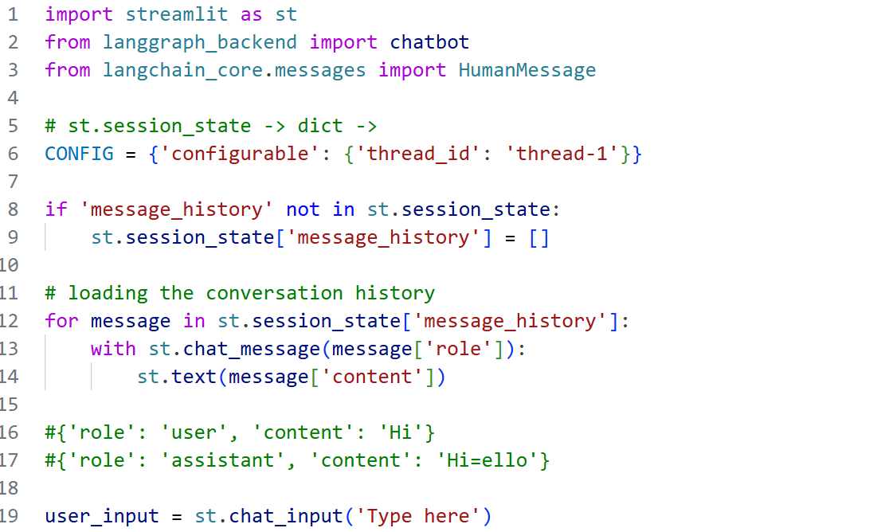
Here we are at first appending the user_input to the key message_history for next time. It then shows the what user asked. And it gets the answer from model but it uses .write_stream instead of normal invoke.
stream_mode='messages' - This tells LangGraph:
"Give me the individual message chunks generated by the LLM."
So instead of receiving only the final state, we receive pieces of the AI message as they are generated.

message_chunk.content for message_chunk, metadata in chatbot.stream(...) is a generator expression.
It means:
For every chunk produced by chatbot.stream(), take only its .content.
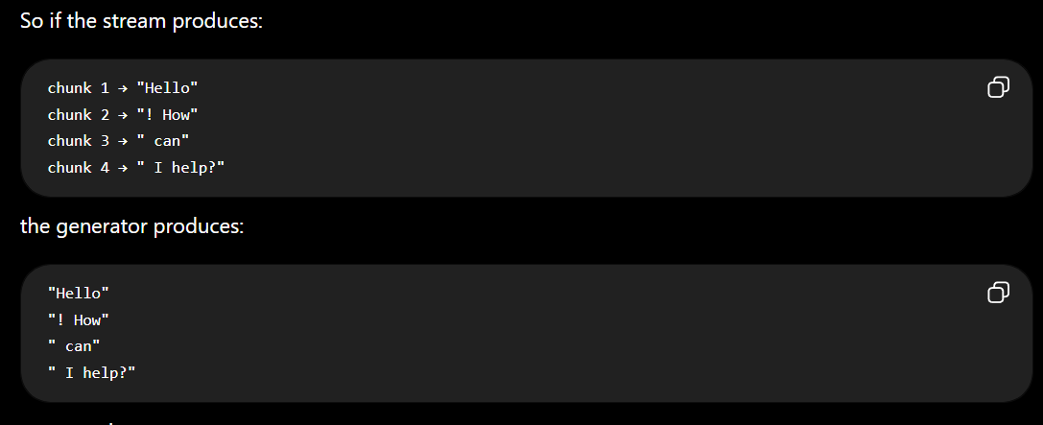
for message_chunk, metadata in chatbot.stream(...) –
each iteration gives us two things:
- message_chunk → current piece of the AI message
- metadata → information about where/how that chunk was generated

